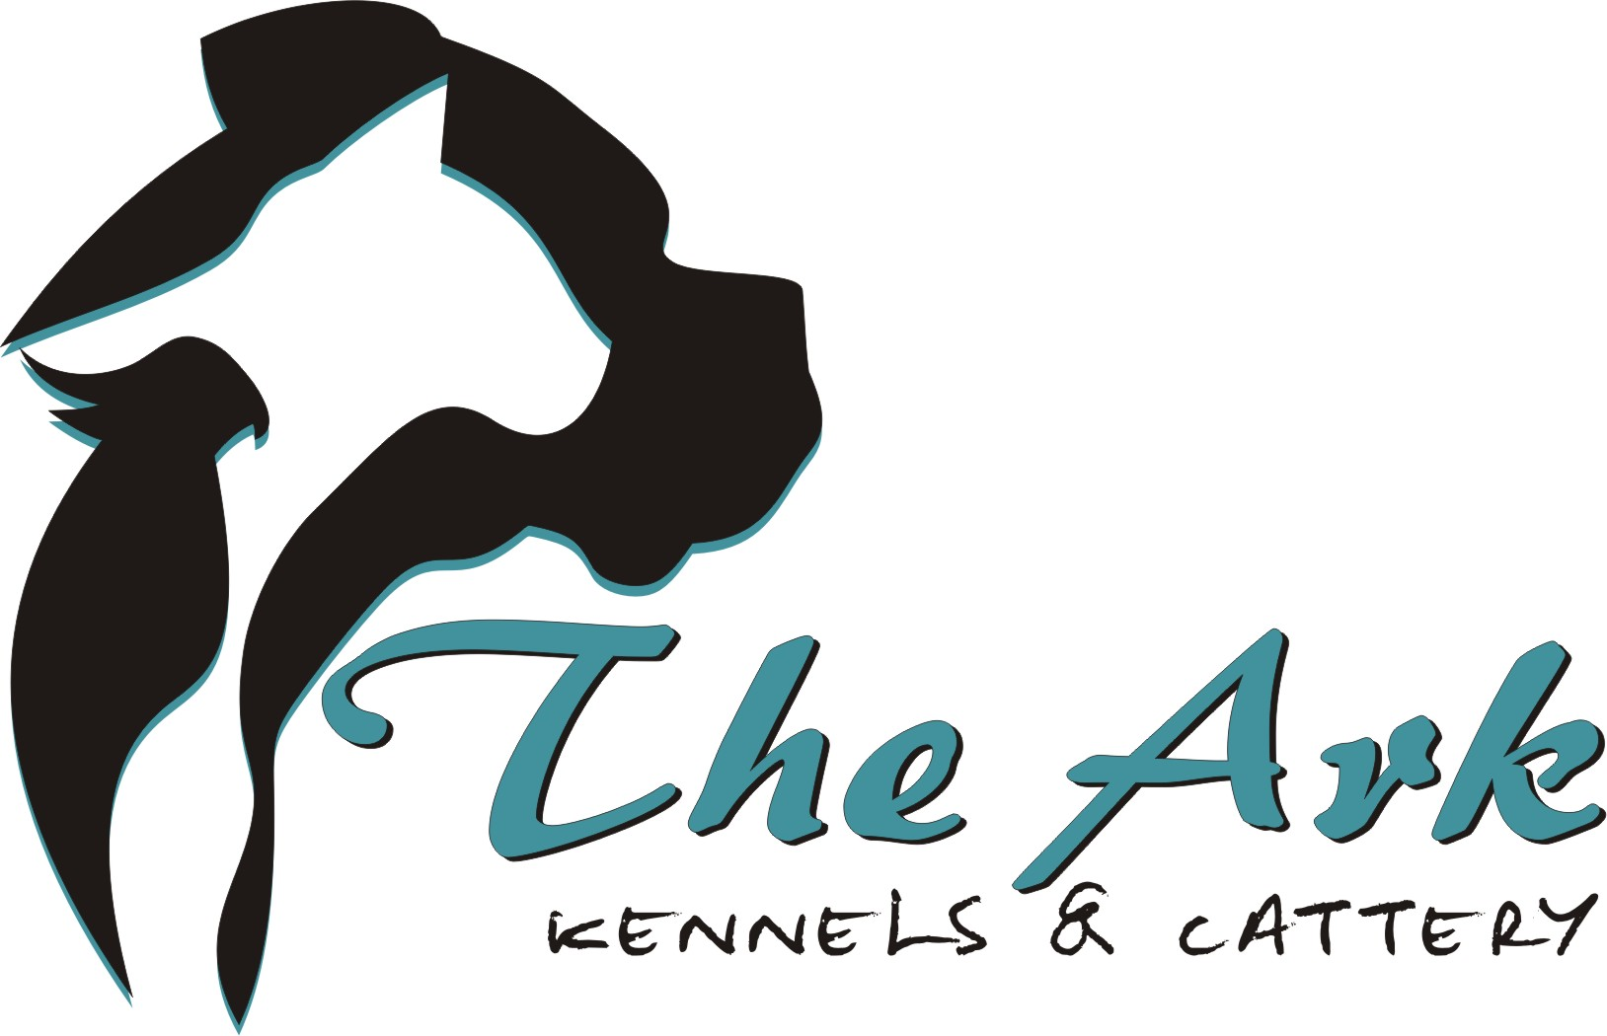
Glenara Street 7
Olive Hill
0788036293
New Client Admission Form:
Guest’s Name: _________________________________________________________________
Sex: _________________________________________________________________
Spayed / Neutered: _________________________________________________________________

Owner’s Information
Name: _________________________________________________________________
Cell Number: _________________________________________________________________
Alternative Number: _________________________________________________________________
Address: _________________________________________________________________

Vet Information
Name / Practice: _________________________________________________________________
Contact Number: _________________________________________________________________
Emergency Number: _________________________________________________________________

Guest’s Information
Canine or Feline:_______________________________________________________________________
AGE: ________________________________________________________________________
BREED: ________________________________________________________________________
Colour: ________________________________________________________________________
Socialized: ________________________________________________________________________
Inoculation record up to date? (please give a copy upon collection or bring original when booking in) _____________________________________________________________________________________
Has he / she ever tried / succeeded in escaping through a fence? ______________________________
What known behavioral problems does he / she have? __________________________________________________________________________________________________________________________________________________________________________
Is he / she frightened by anything / situation?
__________________________________________________________________________________________________________________________________________________________________________
How do you calm him / her in a situation as mentioned above?
__________________________________________________________________________________________________________________________________________________________________________
Does he / she enjoy playing with toys?
__________________________________________________________________________________________________________________________________________________________________________
Does he / she have any health concerns that you are aware of? Please list:
__________________________________________________________________________________________________________________________________________________________________________

Does he / she have any medication we should administer? Please elaborate:
__________________________________________________________________________________________________________________________________________________________________________
Does he / she have any allergies you are aware of? Please list:
__________________________________________________________________________________________________________________________________________________________________________
Is he / she on tick or flea preventatives?
__________________________________________________________________________________________________________________________________________________________________________
Is there anything further you would want to share about him / her to ensure a safe and happy stay?
__________________________________________________________________________________________________________________________________________________________________________
Terms & Conditions:
A full day’s board is charged for both the day of arrival and day of departure. While every possible care and attention at The Ark Kennels & Cattery is given to guests, no responsibility can be accepted for accidents, injury, illness, death, loss or damage of any nature occurring during or subsequent to the guests stay at our establishment. Guests are accepted entirely at owner’s risk. All guests arriving at The Ark Kennels & Cattery will be inspected for any apparent or visible disease or injury.
Guests arriving with fleas or ticks will be given Bravecto (at owner’s expense)
No guests will be accepted / admitted for boarding unless vaccinated according to current veterinary requirements and documentary proof first presented.
All accessories of any guest are taken in at owner’s own risk.
The Ark Kennels & Cattery is entitled at their discretion, and at the expense of the owner, and with a handling fee of R300.00 to engage veterinary services should an emergency arise.
No refunds for early returns will be given. All guests not arriving on the book-in date will automatically forfeit the booking unless prior arrangements are made.
By signing hereof, the signatory indemnifies the proprietor from liability for loss or damage, including consequential damage arising through any cause including without limitation, any veterinary expenses incurred in respect of the guest, sickness or escape and loss of or damage to goods left at The Ark Kennels & Cattery. The signatory undertakes liability for the payment of all charges imposed in terms of this contract and the boarding charges in respect of which it warrants that it is familiar, and agrees that a certificate of indebtedness signed by the proprietor shall be prima facie proof of such indebtedness. Both parties agree to the authority and jurisdiction of the Magistrates Court of Bloemfontein if a civil action is undertaken for the indebtedness, and any other matters that may result from the agreement. The parties choose domicillium citandi et executandi at their respective addresses as set out in this agreement. All documents and correspondence relating to this agreement shall be sent to these addresses. The signatory is requested to and satisfy him- / her- self of the conditions of the accommodation for the intended guest and on the signature hereof warrants that is satisfied with such conditions. I hereby agree to the above conditions and warrants that my animal is healthy and fully inoculated and free of any disease.

____________________________ _______________________
Owner’s Signature: Date:

